**Background Subtraction**

**What is Background Subtraction**

* Background subtraction is a way of eliminating the background from image. To achieve this we extract the moving foreground from the static background.

* Background Subtraction has several use cases in everyday life, It is being used for object segmentation, security enhancement, pedestrian tracking, counting the number of visitors, number of vehicles in traffic etc. It is able to learn and identify the foreground mask.

**How is it used to find motion in a video?**

* Each frame is compared to the background.
* If the pixel value differs significantly, it's marked as "foreground" (i.e., moving object).
* This highlights areas where motion has occurred.

**Background Modelling**



**Background Model**



**After Background Filtering…**



***PROBLEM***

**Frame at Time: t**

**[12, 25, 12, 45]**

**[12, 125, 17, 14]**

**[18, 184, 15, 126]**

**[18, 25, 214, 65]**

**Frame at Time: t+1**

**[12, 25, 12, 45]**

**[12, 125, 125, 14]**

**[18, 15, 184, 126]**

**[18, 25, 214, 65**]

**Result (t+1 - t)**

**[0, 0, , 45]**

**[0, 0, 0, 0]**

**[0, 169, 169, 0]**

**[0, 0, 0, 0**]

**Frame differencing**

Background is estimated to be the previous frame:

B(x, y, t) = I(x, y, t - 1)

Background subtraction then becomes:

I(x, y, t) - 1(x, y, t - 1)| > Th

Background subtraction (BS) is a common and widely used technique for generating a foreground mask (namely, a binary image containing the pixels belonging to moving objects in the scene) by using static cameras.

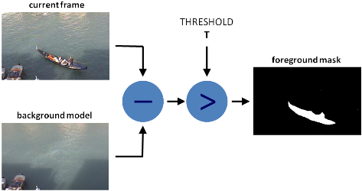

**For example**

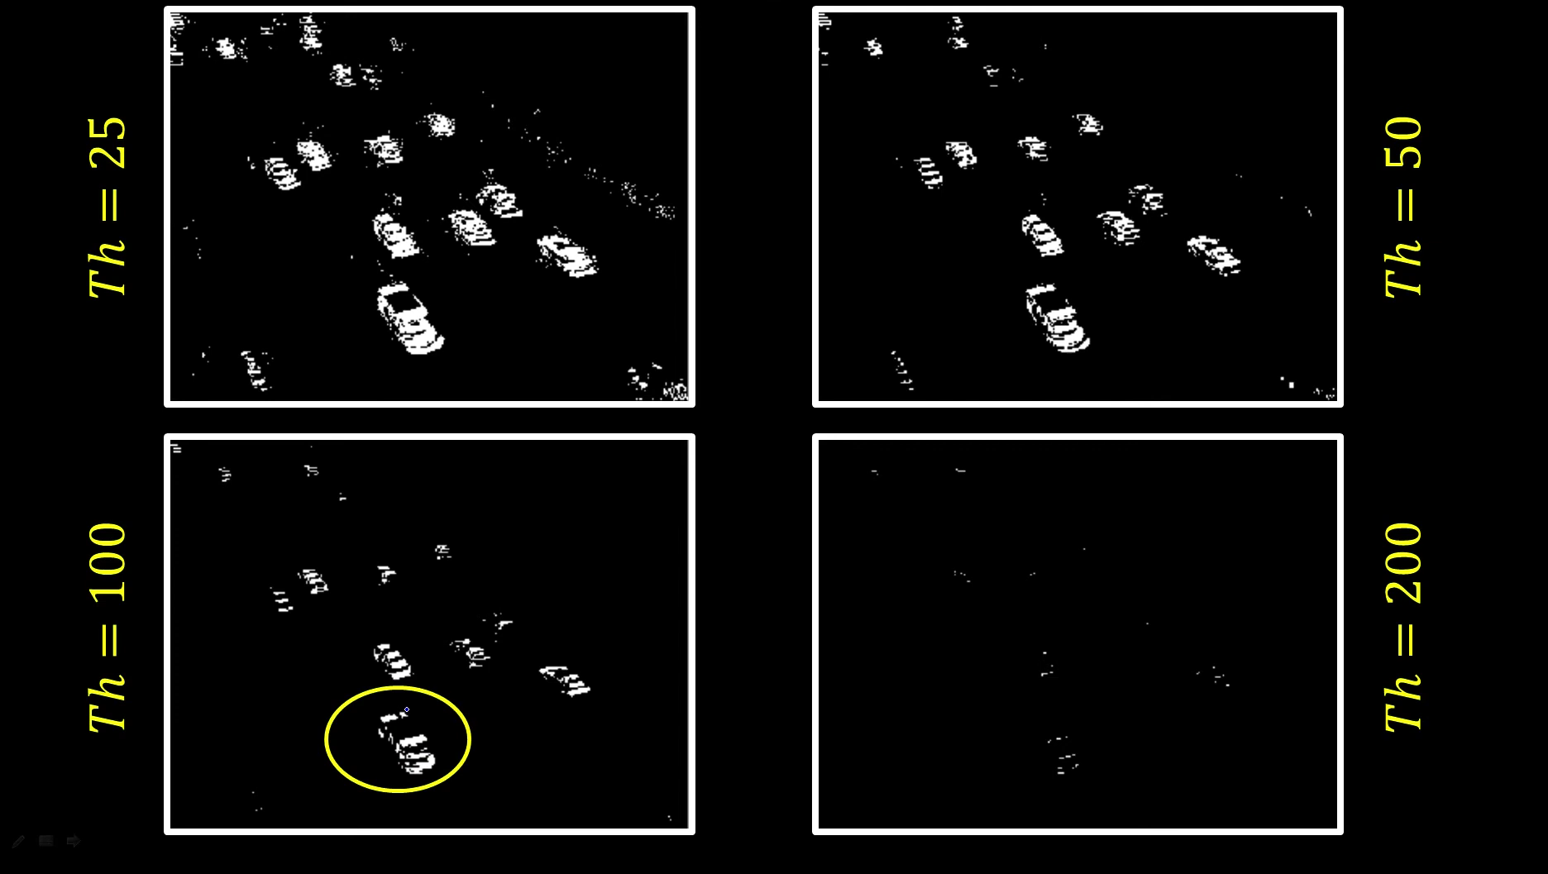

**In OpenCV we have 3 algorithms to do this operation**

**BackgroundSubtractorMOG –** It is a Gaussian Mixture-based Background/Foreground Segmentation Algorithm.

**BackgroundSubtractorMOG2 –** It is also a Gaussian Mixture-based Background/Foreground Segmentation Algorithm. It provides better adaptability to varying scenes due illumination changes etc.

**BackgroundSubtractorGMG –** This algorithm combines statistical background image estimation and per-pixel Bayesian segmentation.

**Advantages**

Simple and Efficient

Effective for Static Cameras

Quick Motion Detection

Foreground Isolation

Useful for Object Tracking

Flexible Implementation

**Disadvantages**

* Sensitive to illumination changes
* Fails with shadows and reflections
* Background changes slowly (e.g., waving trees)
* Requires tuning thresholds for accuracy

**How to overcome the disadvantages:**

* Use adaptive background modeling
* Apply shadow removal techniques
* Combine with temporal filtering or morphological operations
* Use advanced models (e.g., Mixture of Gaussians)